## **Flu Shot Learning: Predict H1N1 and Seasonal Flu Vaccines**

**Hosted by Drivendata**

https://www.drivendata.org/competitions/66/flu-shot-learning/page/210/

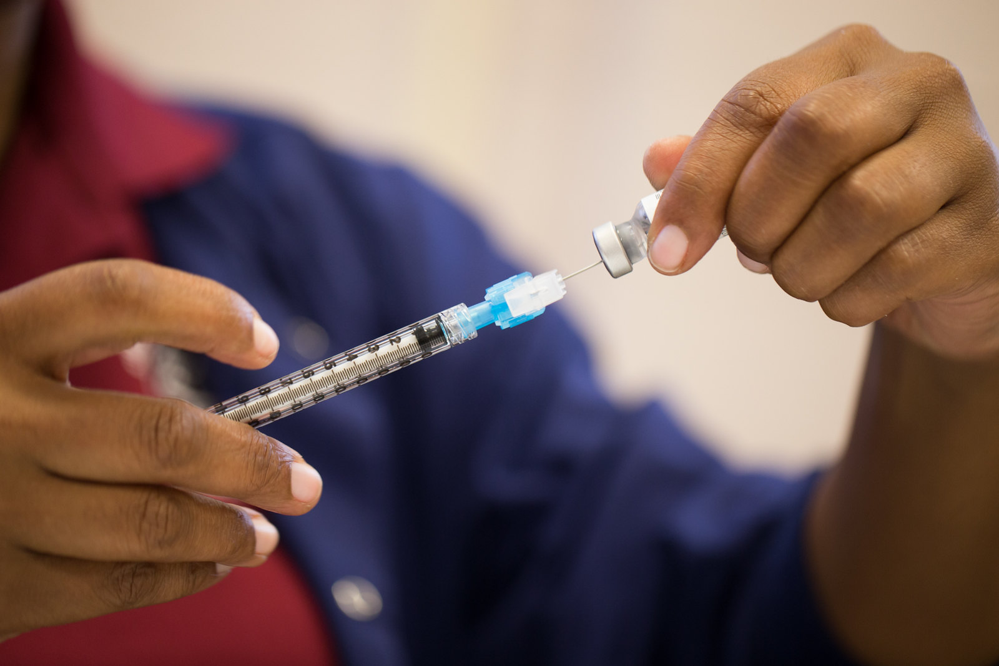

# Overview

**Can you predict whether people got H1N1 and seasonal flu vaccines using information they shared about their backgrounds, opinions, and health behaviors?**

In this challenge, we will take a look at vaccination, a key public health measure used to fight infectious diseases. Vaccines provide immunization for individuals, and enough immunization in a community can further reduce the spread of diseases through "herd immunity."

As of the launch of this competition, vaccines for the COVID-19 virus are still under development and not yet available. The competition will instead revisit the public health response to a different recent major respiratory disease pandemic. Beginning in spring 2009, a pandemic caused by the H1N1 influenza virus, colloquially named "swine flu," swept across the world. Researchers estimate that in the first year, it was responsible for between [151,000 to 575,000 deaths globally](https://www.cdc.gov/flu/pandemic-resources/2009-h1n1-pandemic.html).

A vaccine for the H1N1 flu virus became publicly available in October 2009. In late 2009 and early 2010, the United States conducted the National 2009 H1N1 Flu Survey. This phone survey asked respondents whether they had received the H1N1 and seasonal flu vaccines, in conjunction with questions about themselves. These additional questions covered their social, economic, and demographic background, opinions on risks of illness and vaccine effectiveness, and behaviors towards mitigating transmission. A better understanding of how these characteristics are associated with personal vaccination patterns can provide guidance for future public health efforts.

Data is provided courtesy of the United States [National Center for Health Statistics](https://www.cdc.gov/nchs/index.htm).

U.S. Department of Health and Human Services (DHHS). National Center for Health Statistics. The National 2009 H1N1 Flu Survey. Hyattsville, MD: Centers for Disease Control and Prevention, 2012.

Images courtesy of the [U.S. Navy](https://www.flickr.com/photos/navcent/15607260325/) and the [Fort Meade Public Affairs Office](https://www.flickr.com/photos/ftmeade/15242740638/) via Flickr under the [CC BY 2.0 license](https://creativecommons.org/licenses/by/2.0/legalcode).

# Problem description

Your goal is to predict how likely individuals are to receive their H1N1 and seasonal flu vaccines. Specifically, you'll be predicting two probabilities: one for h1n1_vaccine and one for seasonal_vaccine.

Each row in the dataset represents one person who responded to the National 2009 H1N1 Flu Survey.

## Labels

For this competition, there are two target variables:

* h1n1_vaccine - Whether respondent received H1N1 flu vaccine.
* seasonal_vaccine - Whether respondent received seasonal flu vaccine.

Both are binary variables: 0 = No; 1 = Yes. Some respondents didn't get either vaccine, others got only one, and some got both. This is formulated as a multilabel (and not multiclass) problem.

## The features in this dataset

You are provided a dataset with 36 columns. The first column respondent_id is a unique and random identifier. The remaining 35 features are described below.

For all binary variables: 0 = No; 1 = Yes.

* h1n1_concern - Level of concern about the H1N1 flu.
  + 0 = Not at all concerned; 1 = Not very concerned; 2 = Somewhat concerned; 3 = Very concerned.
* h1n1_knowledge - Level of knowledge about H1N1 flu.
  + 0 = No knowledge; 1 = A little knowledge; 2 = A lot of knowledge.
* behavioral_antiviral_meds - Has taken antiviral medications. (binary)
* behavioral_avoidance - Has avoided close contact with others with flu-like symptoms. (binary)
* behavioral_face_mask - Has bought a face mask. (binary)
* behavioral_wash_hands - Has frequently washed hands or used hand sanitizer. (binary)
* behavioral_large_gatherings - Has reduced time at large gatherings. (binary)
* behavioral_outside_home - Has reduced contact with people outside of own household. (binary)
* behavioral_touch_face - Has avoided touching eyes, nose, or mouth. (binary)
* doctor_recc_h1n1 - H1N1 flu vaccine was recommended by doctor. (binary)
* doctor_recc_seasonal - Seasonal flu vaccine was recommended by doctor. (binary)
* chronic_med_condition - Has any of the following chronic medical conditions: asthma or an other lung condition, diabetes, a heart condition, a kidney condition, sickle cell anemia or other anemia, a neurological or neuromuscular condition, a liver condition, or a weakened immune system caused by a chronic illness or by medicines taken for a chronic illness. (binary)
* child_under_6_months - Has regular close contact with a child under the age of six months. (binary)
* health_worker - Is a healthcare worker. (binary)
* health_insurance - Has health insurance. (binary)
* opinion_h1n1_vacc_effective - Respondent's opinion about H1N1 vaccine effectiveness.
  + 1 = Not at all effective; 2 = Not very effective; 3 = Don't know; 4 = Somewhat effective; 5 = Very effective.
* opinion_h1n1_risk - Respondent's opinion about risk of getting sick with H1N1 flu without vaccine.
  + 1 = Very Low; 2 = Somewhat low; 3 = Don't know; 4 = Somewhat high; 5 = Very high.
* opinion_h1n1_sick_from_vacc - Respondent's worry of getting sick from taking H1N1 vaccine.
  + 1 = Not at all worried; 2 = Not very worried; 3 = Don't know; 4 = Somewhat worried; 5 = Very worried.
* opinion_seas_vacc_effective - Respondent's opinion about seasonal flu vaccine effectiveness.
  + 1 = Not at all effective; 2 = Not very effective; 3 = Don't know; 4 = Somewhat effective; 5 = Very effective.
* opinion_seas_risk - Respondent's opinion about risk of getting sick with seasonal flu without vaccine.
  + 1 = Very Low; 2 = Somewhat low; 3 = Don't know; 4 = Somewhat high; 5 = Very high.
* opinion_seas_sick_from_vacc - Respondent's worry of getting sick from taking seasonal flu vaccine.
  + 1 = Not at all worried; 2 = Not very worried; 3 = Don't know; 4 = Somewhat worried; 5 = Very worried.
* age_group - Age group of respondent.
* education - Self-reported education level.
* race - Race of respondent.
* sex - Sex of respondent.
* income_poverty - Household annual income of respondent with respect to 2008 Census poverty thresholds.
* marital_status - Marital status of respondent.
* rent_or_own - Housing situation of respondent.
* employment_status - Employment status of respondent.
* hhs_geo_region - Respondent's residence using a 10-region geographic classification defined by the U.S. Dept. of Health and Human Services. Values are represented as short random character strings.
* census_msa - Respondent's residence within metropolitan statistical areas (MSA) as defined by the U.S. Census.
* household_adults - Number of other adults in household, top-coded to 3.
* household_children - Number of children in household, top-coded to 3.
* employment_industry - Type of industry respondent is employed in. Values are represented as short random character strings.
* employment_occupation - Type of occupation of respondent. Values are represented as short random character strings.

### Feature data example

For example, a single row in the dataset, has these values:

| Field | Value |
| --- | --- |
| h1n1_concern | 1 |
| h1n1_knowledge | 0 |
| behavioral_antiviral_meds | 0 |
| behavioral_avoidance | 0 |
| behavioral_face_mask | 0 |
| behavioral_wash_hands | 0 |
| behavioral_large_gatherings | 0 |
| behavioral_outside_home | 1 |
| behavioral_touch_face | 1 |
| doctor_recc_h1n1 | 0 |
| doctor_recc_seasonal | 0 |
| chronic_med_condition | 0 |
| child_under_6_months | 0 |
| health_worker | 0 |
| health_insurance | 1 |
| opinion_h1n1_vacc_effective | 3 |
| opinion_h1n1_risk | 1 |
| opinion_h1n1_sick_from_vacc | 2 |
| opinion_seas_vacc_effective | 2 |
| opinion_seas_risk | 1 |
| opinion_seas_sick_from_vacc | 2 |
| age_group | 55 - 64 Years |
| education | < 12 Years |
| race | White |
| sex | Female |
| income_poverty | Below Poverty |
| marital_status | Not Married |
| rent_or_own | Own |
| employment_status | Not in Labor Force |
| hhs_geo_region | oxchjgsf |
| census_msa | Non-MSA |
| household_adults | 0 |
| household_children | 0 |
| employment_industry | NaN |
| employment_occupation | NaN |